Frustum

Definition
# Source: AI Source: Provided by: [Data Path: Persons Table -> ID Column: 1, Name_En Column: Motasem Essam] -> From: [ChatGPT] on [7/25/2026]
A frustum is a three-dimensional geometric solid formed when a cone or pyramid is cut by a plane parallel to its base and the smaller top portion is removed.
The resulting solid has two parallel bases, except in generalized terminology where a frustum may refer to a truncated solid with other cross-sectional relationships.
Frustums are commonly classified into frustums of pyramids and frustums of cones.
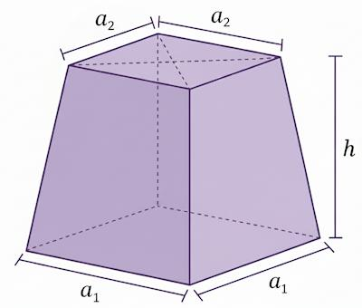
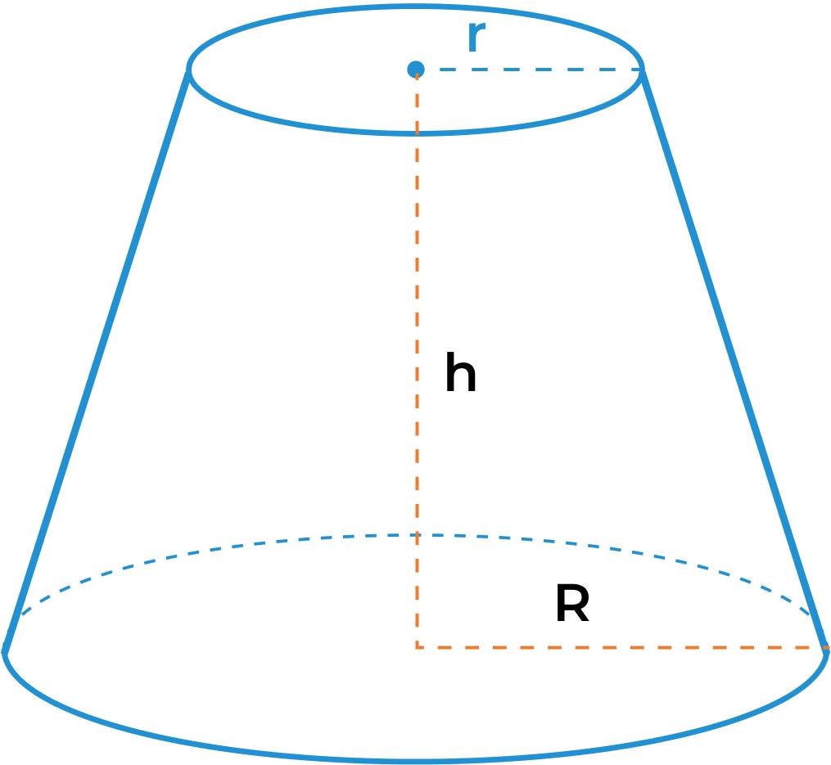
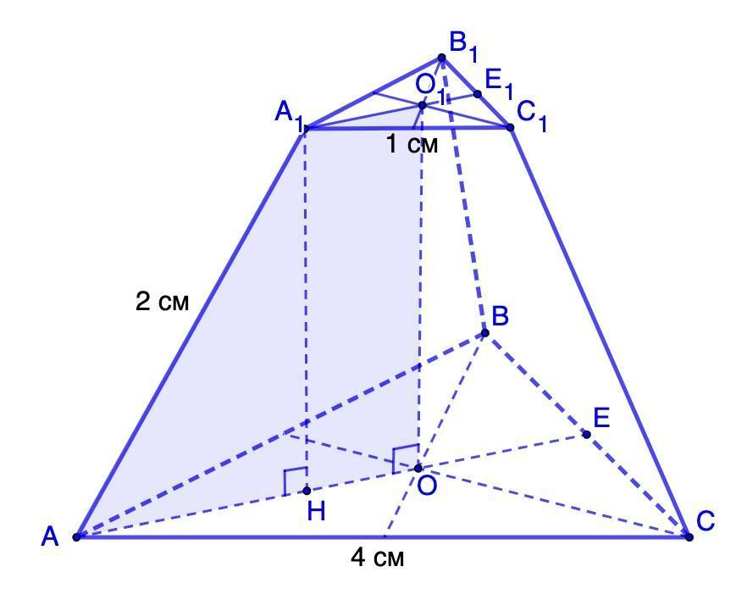

Simple Definition
# Source: AI Source: Provided by: [Data Path: Persons Table -> ID Column: 1, Name_En Column: Motasem Essam] -> From: [ChatGPT] on [7/25/2026]
A frustum is the lower part of a pyramid or cone left after its top is cut off by a plane parallel to its base.
Examples include a tapered bucket, a truncated pyramid, and a lampshade shaped like part of a cone.

Classification Tree
# Source: AI Source: Provided by: [Data Path: Persons Table -> ID Column: 1, Name_En Column: Motasem Essam] -> From: [ChatGPT] on [7/25/2026]
Frustum
Frustum of a Pyramid
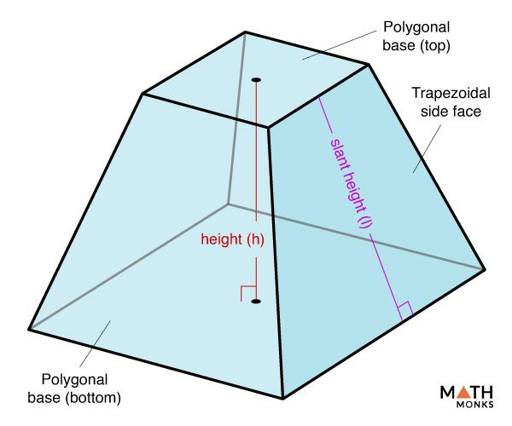
Polygonal parallel bases
Frustum of a Cone
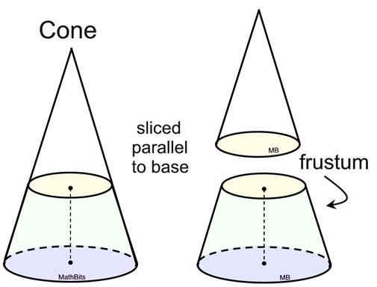
Circular parallel bases
Further classifications
By base shape, regularity, and orientation

Types of Frustums

Frustum of a Pyramid
# Source: AI Source: Provided by: [Data Path: Persons Table -> ID Column: 1, Name_En Column: Motasem Essam] -> From: [ChatGPT] on [7/25/2026]
A pyramid frustum is formed by cutting a pyramid with a plane parallel to its polygonal base and removing the top portion.
Its bases are similar polygons, and its lateral faces are generally trapezoids.
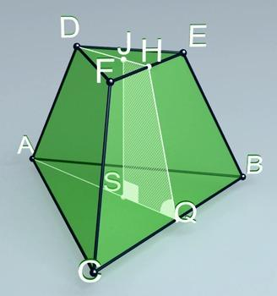
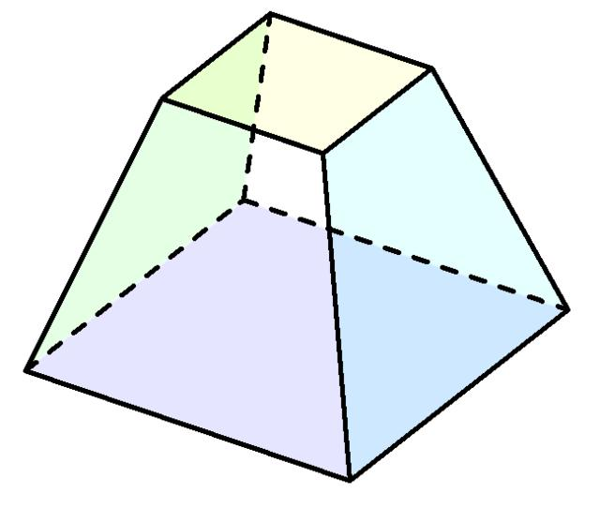
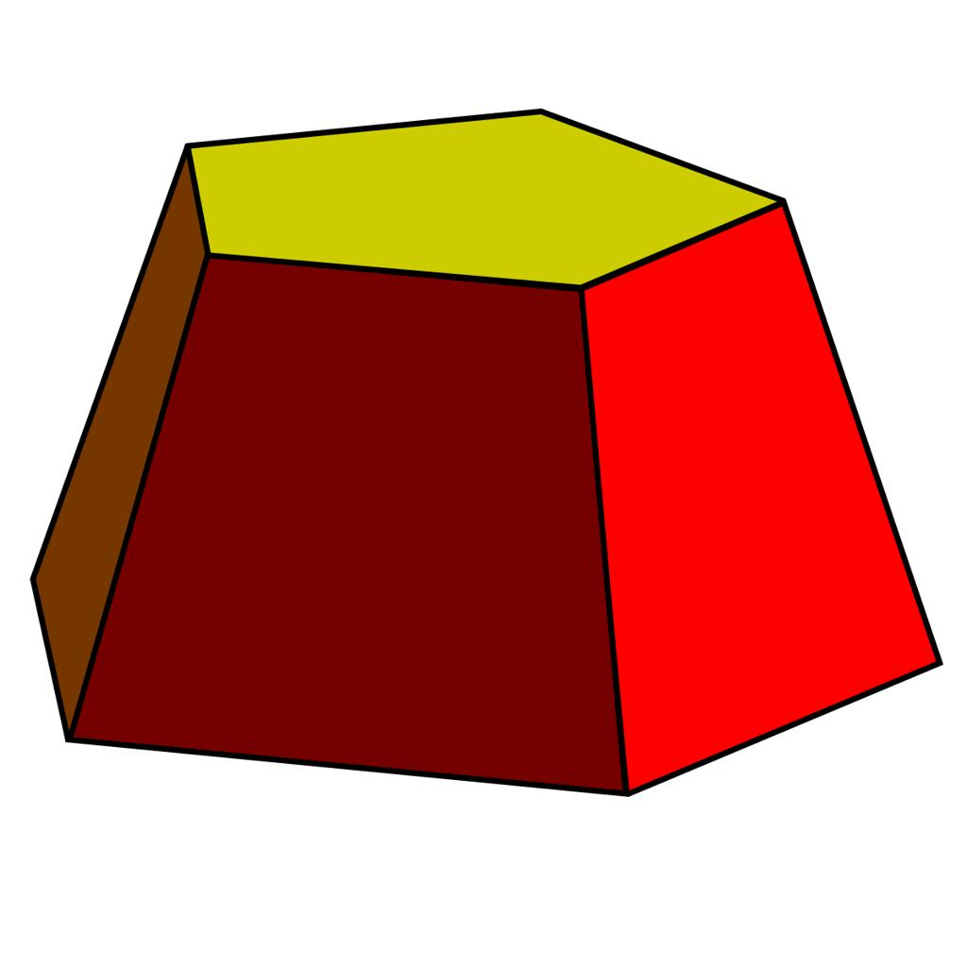
Types by base shape include:
- Triangular pyramid frustum
- Quadrilateral pyramid frustum
- Pentagonal pyramid frustum
- Hexagonal pyramid frustum
- $n$-gonal pyramid frustum
Types by orientation and base regularity include:
- Right pyramid frustum
- Oblique pyramid frustum
- Regular pyramid frustum
- Irregular pyramid frustum

Frustum of a Cone
# Source: AI Source: Provided by: [Data Path: Persons Table -> ID Column: 1, Name_En Column: Motasem Essam] -> From: [ChatGPT] on [7/25/2026]
A conical frustum is formed by cutting a cone with a plane parallel to its circular base and removing the smaller top cone.
It has two parallel circular bases and one curved lateral surface.
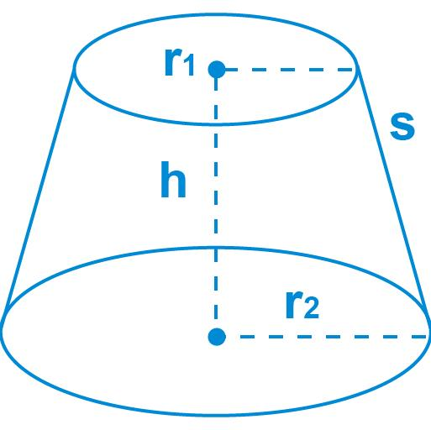
Common classifications include:
- Right circular frustum: The axis is perpendicular to the base planes.
- Oblique conical frustum: The axis is inclined to the base planes.
A right circular frustum has circular bases with a common central axis perpendicular to them.

Key Characteristics of a Frustum
# Source: AI Source: Provided by: [Data Path: Persons Table -> ID Column: 1, Name_En Column: Motasem Essam] -> From: [ChatGPT] on [7/25/2026]
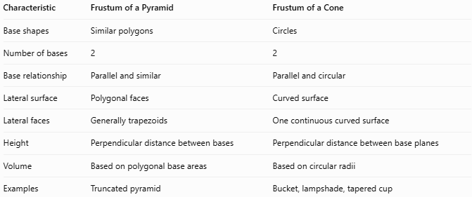
Characteristic | Frustum of a Pyramid | Frustum of a Cone
Base shapes | Similar polygons | Circles
Number of bases | 2 | 2
Base relationship | Parallel and similar | Parallel and circular
Lateral surface | Polygonal faces | Curved surface
Lateral faces | Generally trapezoids | One continuous curved surface
Height | Perpendicular distance between bases | Perpendicular distance between base planes
Volume | Based on polygonal base areas | Based on circular radii
Examples | Truncated pyramid | Bucket, lampshade, tapered cup

Main Components of a Frustum
# Source: AI Source: Provided by: [Data Path: Persons Table -> ID Column: 1, Name_En Column: Motasem Essam] -> From: [ChatGPT] on [7/25/2026]
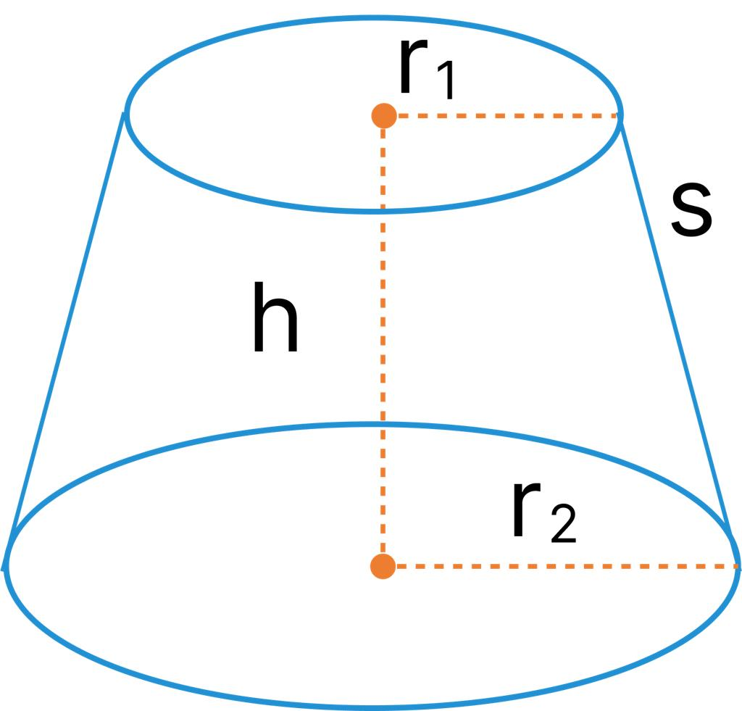
- Lower base: The larger base, with area $B_{1}$.
- Upper base: The smaller parallel base, with area $B_{2}$.
- Height ($h$): The perpendicular distance between the two base planes.
- Lateral surface: The side surface connecting the bases.
- Slant height ($s$): The sloping distance along the lateral surface, used in the relevant surface-area formulas.
- Axis: The line joining the centers of the bases when those centers define the solid's axis.
For a conical frustum, $R$ usually denotes the larger radius and $r$ the smaller radius.

Mathematical Representations and Formulas

Volume of a Pyramid Frustum
# Source: AI Source: Provided by: [Data Path: Persons Table -> ID Column: 1, Name_En Column: Motasem Essam] -> From: [ChatGPT] on [7/25/2026]
$$\boxed{V=\frac{h}{3}\left(B_{1}+B_{2}+\sqrt{B_{1}B_{2}}\right)}$$
Where:
- $B_{1}$ = lower base area.
- $B_{2}$ = upper base area.
- $h$ = perpendicular height.

Volume of a Conical Frustum
# Source: AI Source: Provided by: [Data Path: Persons Table -> ID Column: 1, Name_En Column: Motasem Essam] -> From: [ChatGPT] on [7/25/2026]
$$\boxed{V=\frac{πh}{3}\left(R^{2}+r^{2}+Rr\right)}$$
Where:
- $R$ = lower radius.
- $r$ = upper radius.
- $h$ = perpendicular height.

Lateral Surface Area of a Conical Frustum
# Source: AI Source: Provided by: [Data Path: Persons Table -> ID Column: 1, Name_En Column: Motasem Essam] -> From: [ChatGPT] on [7/25/2026]
For a right circular frustum:
$$\boxed{A_{L}=π\left(R+r\right)s}$$
The slant height is:
$$\boxed{s=\sqrt{h^{2}+{\left(R-r\right)}^{2}}}$$

Total Surface Area of a Conical Frustum
# Source: AI Source: Provided by: [Data Path: Persons Table -> ID Column: 1, Name_En Column: Motasem Essam] -> From: [ChatGPT] on [7/25/2026]
Including both circular bases:
$$\boxed{A_{T}=πR^{2}+πr^{2}+π\left(R+r\right)s}$$
Equivalently:
$$\boxed{A_{T}=π\left[R^{2}+r^{2}+\left(R+r\right)s\right]}$$

Surface Area of a Pyramid Frustum
# Source: AI Source: Provided by: [Data Path: Persons Table -> ID Column: 1, Name_En Column: Motasem Essam] -> From: [ChatGPT] on [7/25/2026]
For a pyramid frustum:
$$\boxed{A_{T}=B_{1}+B_{2}+A_{L}}$$
The lateral area $A_{L}$ is the sum of the areas of all lateral faces. For a regular right pyramid frustum with common slant height $s$:
$$\boxed{A_{L}=\frac{1}{2}\left(P_{1}+P_{2}\right)s}$$
Here, $P_{1}$ and $P_{2}$ are the perimeters of the lower and upper bases.

Worked Examples
# Source: AI Source: Provided by: [Data Path: Persons Table -> ID Column: 1, Name_En Column: Motasem Essam] -> From: [ChatGPT] on [7/25/2026]
Example 1: Volume of a Pyramid Frustum
A pyramid frustum has a lower base area of $100{\text{ cm}}^{2}$, an upper base area of $25{\text{ cm}}^{2}$, and a height of $12\text{ cm}$.
$$V=\frac{12}{3}\left(100+25+\sqrt{100×25}\right)$$
$$V=4\left(100+25+50\right)$$
$$\boxed{V=700{\text{ cm}}^{3}}$$
Example 2: Volume of a Conical Frustum
A right circular frustum has a lower radius of $6\text{ cm}$, an upper radius of $3\text{ cm}$, and a height of $8\text{ cm}$.
$$V=\frac{π\left(8\right)}{3}\left(6^{2}+3^{2}+6×3\right)$$
$$V=\frac{8π}{3}\left(36+9+18\right)$$
$$\boxed{V=168π{\text{ cm}}^{3}}$$
Approximately:
$$V≈527.79{\text{ cm}}^{3}$$
Example 3: Slant Height of a Conical Frustum
A right circular frustum has a height of $8\text{ cm}$, a lower radius of $6\text{ cm}$, and an upper radius of $3\text{ cm}$.
$$s=\sqrt{h^{2}+{\left(R-r\right)}^{2}}$$
$$s=\sqrt{8^{2}+{\left(6-3\right)}^{2}}$$
$$s=\sqrt{64+9}$$
$$\boxed{s=\sqrt{73}≈8.54\text{ cm}}$$

Comparison with Related Geometric Solids
# Source: AI Source: Provided by: [Data Path: Persons Table -> ID Column: 1, Name_En Column: Motasem Essam] -> From: [ChatGPT] on [7/25/2026]
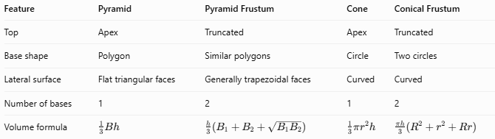
Feature | Pyramid | Pyramid Frustum | Cone | Conical Frustum
Top | Apex | Truncated | Apex | Truncated
Base shape | Polygon | Similar polygons | Circle | Two circles
Lateral surface | Flat triangular faces | Generally trapezoidal faces | Curved | Curved
Number of bases | 1 | 2 | 1 | 2
Volume formula | $$\frac{1}{3}Bh$$ | $$\frac{h}{3}\left(B_{1}+B_{2}+\sqrt{B_{1}B_{2}}\right)$$ | $$\frac{1}{3}πr^{2}h$$ | $$\frac{πh}{3}\left(R^{2}+r^{2}+Rr\right)$$

Applications of Frustums
# Source: AI Source: Provided by: [Data Path: Persons Table -> ID Column: 1, Name_En Column: Motasem Essam] -> From: [ChatGPT] on [7/25/2026]
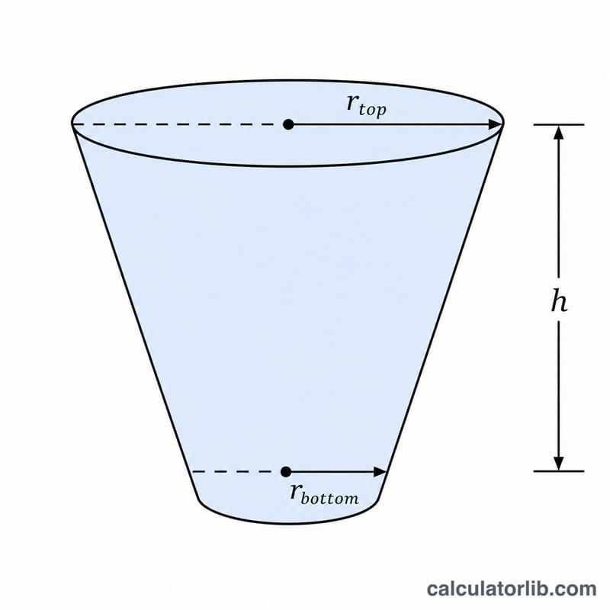
Containers
Buckets, waste bins, tapered cups, and storage containers often approximate conical frustums.

Architecture
Truncated pyramids are used in building designs, roof structures, and decorative architectural elements.
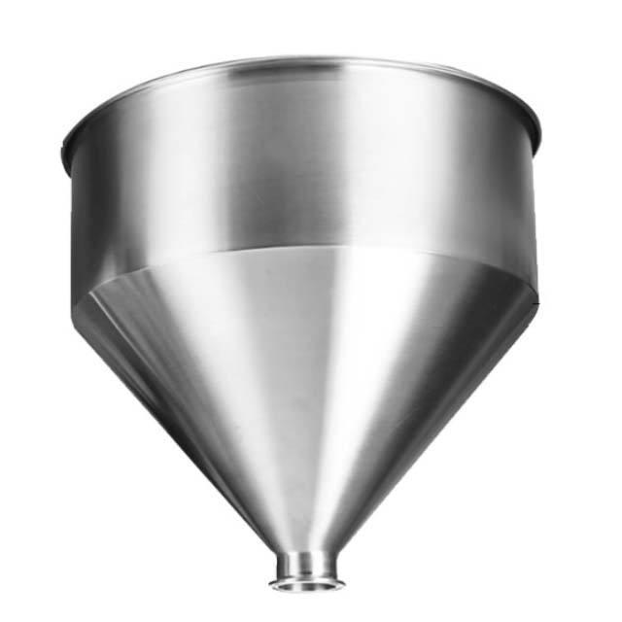
Engineering
Frustum geometry helps engineers calculate the capacity and material requirements of hoppers, ducts, and tapered components.

Product Design
Lampshades, decorative objects, and other tapered products can be designed using frustum dimensions.

Key Points
# Source: AI Source: Provided by: [Data Path: Persons Table -> ID Column: 1, Name_En Column: Motasem Essam] -> From: [ChatGPT] on [7/25/2026]
- A frustum is commonly formed by cutting a cone or pyramid parallel to its base and removing the smaller top portion.
- The resulting solid has two parallel, similar bases.
- Frustums are classified into pyramid frustums and conical frustums.
- Pyramid frustums have polygonal bases and generally flat trapezoidal lateral faces.
- Conical frustums have circular bases and a curved lateral surface.
- The height is the perpendicular distance between the base planes.
- Volume and surface-area formulas depend on whether the frustum comes from a pyramid or a cone.

Conclusion
# Source: AI Source: Provided by: [Data Path: Persons Table -> ID Column: 1, Name_En Column: Motasem Essam] -> From: [ChatGPT] on [7/25/2026]
A frustum is an important solid in three-dimensional geometry, representing the truncated portion of a pyramid or cone. Its two main types are the frustum of a pyramid and the frustum of a cone. Understanding the bases, height, lateral surface, and slant height makes it possible to calculate its volume and surface area and distinguish it from related geometric solids.

